Work Experience
at

Software Cornwall Members are hosting and supporting a work experience week where 24 students can work for a week in a software engineering team on a software development project alongside industry professionals. The week is organised so you can gain real experience in software development and delivery in a working environment.
If, having read all the information below, you would like to be considered for a work experience placement at Software Cornwall, please complete the application form provided and include a covering letter that explains why you would particularly like a work placement with us.
The closing date for applications is 19th February 2016
Due to the level of demand, we are only able to offer 24 students one week of work experience from 4-8th July 2016 hosted at Barncoose Gateway Business Centre in Redruth. We are not able to offer other dates or locations. If your school work experience week is an alternative week, please speak to your teacher as you may be able to change your dates to be able to attend.
You will be notified if your application has been successful by the end of February along with next steps through the email you provide on your application. Thank you for your interest in Software Cornwall work experience.

Name of Contact for Work Experience
Belinda Waldock, Director
Software Cornwall Ltd
Gateway Business Centre, Barncoose, Redruth, TR15 1SP Cornwall
07776094925
info@softwarecornwall.org
www.softwarecornwall.org

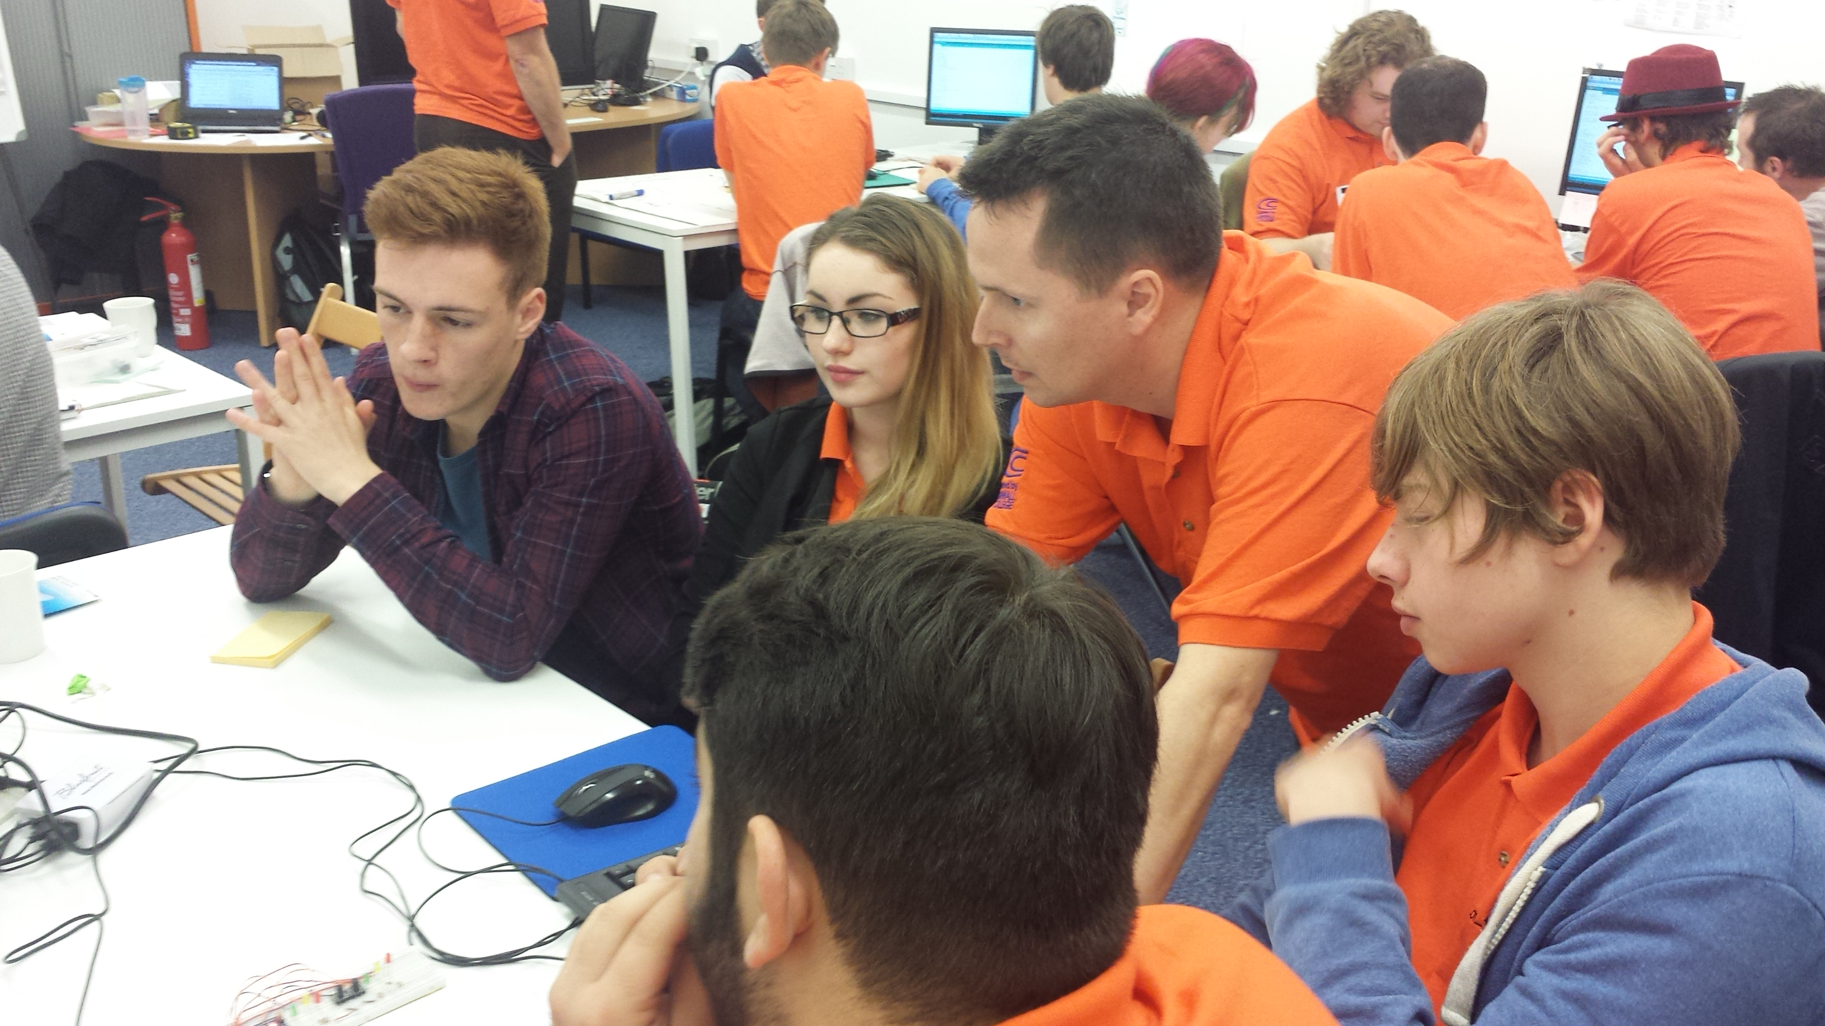
Software Cornwall is an open and collaborative group of Software Development enterprises, education providers and business support organisations based in Cornwall working together to grow the software engineering sector in Cornwall. Software Cornwall Ltd is a Not-For-Profit organisation. A key objective of Software Cornwall is to support young people into careers in software engineering.
Recently members have been overwhelmed by requests for experience which we are delighted to receive. Due to the nature of the industry providing an engaging and hands on experience placement for students is very difficult to provide meaning places are in short supply.
To solve this problem companies have decided to collaborate and volunteer their time and developers to help run a work experience week for students that will give you a practical and fun experience of working as a software engineer building digital products and solutions.
Your Experience
As part of the Software Cornwall Experience you will work on a project with other students and a software expert as your mentor. You will learn how to create and deliver a software product as part of a development team during the week.
For the experience the group will take the form of an exciting new start up that has won a contract to deliver a software driven product, in teams with your mentor you will work on a number of challenges in order to fulfil the contract. You will learn how to identify, code, test and deliver your solution.
On the final day you will have the opportunity to present your work to local employers and developers and talk to them more about their businesses, jobs, career opportunities and get advice on the best pathway to working in the software sector in Cornwall
The work experience week is supported by the members of Software Cornwall including;

Bluefruit - Embedded Software Specialists

From creating embedded software for products like electric bikes to water purifiers, or producing professional data logging and performance analysis solutions for motorsport and sailing applications, the Bluefruit team build quality software solutions.

A member of the Bluefruit development team will be a volunteer mentor at the experience week, and are also hosting the experience in their offices at Barncoose in Redruth.

Cornwall College
The college has a strong software development team to create and manage its internal and online systems, as well as providing skills and training in computer science.
Mike Trebilcock will be the lead mentor for the week, he is Head Geek at Software Cornwall as well as working for Cornwall College. Mike has had his own software business and is a keen coder. He also champions Code Clubs across Cornwall Schools and in his spare time runs marathons!

MyMediaLab
MyMediaLab are dedicated to building a better web with Solid, scalable custom applications. They offer high-quality custom web applications.
A member of the MyMediaLab development team will be a volunteer mentor.

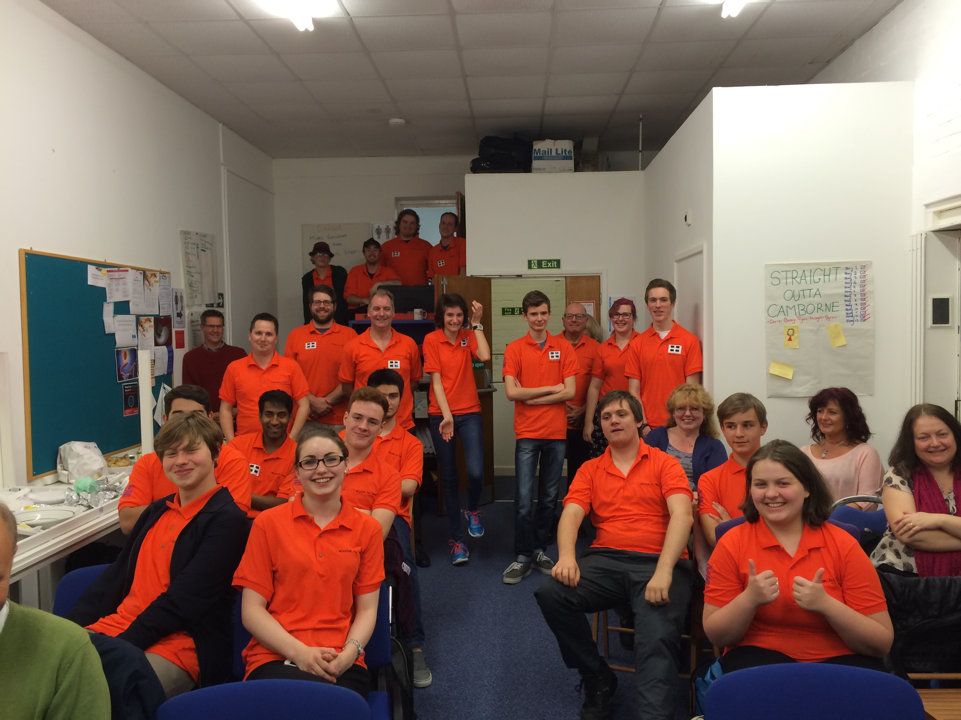

Job Description
Job Title: | Software Engineer
Hours: | Monday – Friday 4-8th July 2016  9am – 4.30pm
Main Function: | A unique opportunity to be part of an exciting new start up company that has won a contract to deliver a software driven product.  As part of our development team you will help to deliver the solution and overcome challenges in order to fulfil this new contract.  You will learn how to identify, code and test your solution as part of your role.  Please be aware this business has been made up for the Software Cornwall experience and is entirely fictional.

Person Specification

Personal Qualities & Attitudes | Must be a good time-keeper.  Smart appearance. Dress code is smart casual clothing.  Good communication skills and friendly manner.  Enthusiastic approach to learning.  The ability to comply with instruction and follow set systems.  The ability to work with others and independently.  The ability to be flexible and adaptable in dealing with different tasks.
Special Knowledge & Skills | An interest in Computer Science and Software Engineering.  Knowledge of coding would be an advantage but is not essential.

General Information
Travel  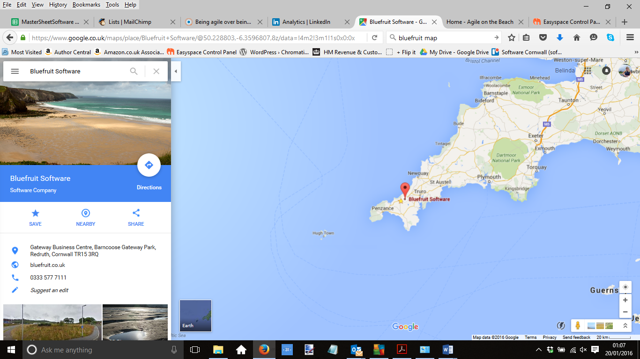 | 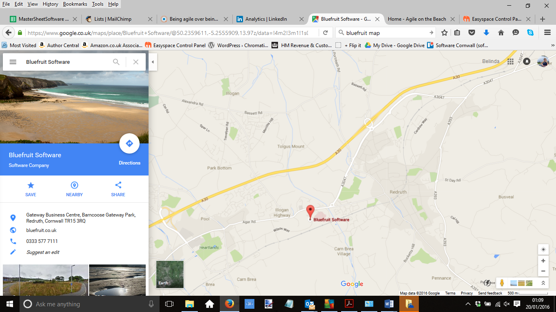
Dress The dress code is smart/casual
Arrival You should arrive for work on time each day and use the bell to ring Bluefruit reception to access the offices and then report to their reception to let them know you have arrived.
Induction including Health and Safety On your first day, you will be given a health and safety briefing, including emergency procedures, before you begin any work. You will be shown around the premises and introduced to the staff. Before your placement begins, you will be given the name of your link person and if at any point during the week you are late or ill, please contact this person as soon as possible.
Lunch One hour (time to be agreed: normally 12.30pm until 1.30pm, although lunchtimes may vary due to your work programme on a given day). You will be required to bring a packed lunch. There is also a café on site which serves sandwiches, snacks and drinks.

Programme for the Week Your individual programme for the week will be given to you on your first day.
Working with different members of staff/mentors: During the week, you will have a chance of working alongside our mentors and have the opportunity to carry out different tasks and duties that they will advise and support you to complete. These tasks and duties are all subject to change and the mentors may vary from day to day. We hope that you will be flexible in your approach to your work experience!
A template of the application form is given below for you to prepare your application
Please complete your application online at

http://www.softwarecornwall.org/schools-work-experience-2016/

If you are unable to complete the application online you can email it to
Belinda Waldock : info@softwarecornwall.org

Or you may post your application to

Belinda Waldock
Software Cornwall – Work Experience Application
Bluefruit Software
Gateway Business Centre
Barncoose
Redruth
TR15 1SP Cornwall

Work Experience Application Form
Name:
Date of Birth:  Current School Year: | Parent or Guardian:
Address:  Email Address: | Contact Telephone Numbers Home:  Parent/Guardian Emergency Contact Number:
Name of School:
I am able to attend the Software Cornwall Experience from 4-8th July at Barncoose, Redruth | YES / NO * please delete as appropriate

What skills and knowledge do you have that would make you suitable for a
placement with us? (Please tick all that apply and give a supporting example)
Organisational skills
Communication skills
Working in a team and/or on own initiative
Knowledge, skill or interest in Computer Science
Personable Skills
(eg trustworthy, polite, enthusiastic)
Examples of Software Projects you have worked on at school, at clubs or at home
Please attach your Covering Letter, which should say why you would like a placement with us,
as well as anything else that you feel would help your application
Signature of Student |  | Date
The information provided on this form shall be processed by the placement provider in accordance with the Data Protection Act 1998. The information is collected for the purposes of administering the work experience scheme only and will be used by your school, the Cornwall Education Business Partnership and the placement provider.

